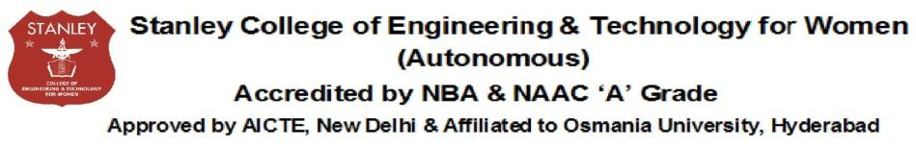

Department of Computer Science & Engineering
Major Project Date:

Batch No | Roll No | Name | Title

Abstract (Max of 300 words)

Coordinator: Mrs.Shugufta Fatima HOD: Dr. R. Madana Mohana

